Activity paper
Every year Russian people celebrate Victory Day. This spring we will have it on Saturday, May 9. In Tselina there are several streets named after heroes of the Great Patriotic War. One of them is Mikhail Andreevich Dudka.

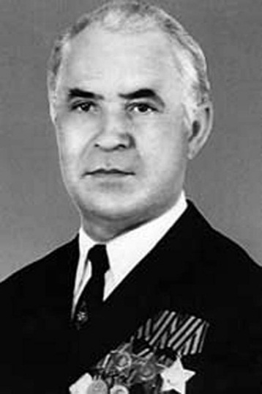
Complete the information about M.A. Dudka. Fill in the gaps with the verb to be in the correct form.
To be – быть, находиться, являться – какую из этих форм вы используете в рассказе?
Present Simple  Am, is, are | Past Simple  Was, were | Future Simple  Will be | Present Perfect  Have/has been

Mikhail Andreevich Dudka ____ born in 1922.
His father ________ a worker.
In 1936 Mikhail ________ a master shoemaker (мастер-обувщик).
Mikhail ______ 19 years old when in October 1941 he went to the army.
M. Dudka ______ at the front in March 1943. He fought bravely, and ______awarded (награжден) the order of Glory of the 3rd degree (Орденом Славы 3-й степени) in 1944.
In February 1945 Mikhail Dudka _____ the commander of the mortar crew (командиром миномётного расчёта). He fought actively in Poland and _____ awarded the order of Glory of the 2nd degree in May 1945.
In May 1946 Dudka M.A. _______ awarded the order of Glory of the 1st degree.
In November 1946 Mikhail Andreevich Dudka came back to Tselina, worked in our native place. He took an active part in the Patriotic education of young people.
He died in September 2004.
People are proud of such heroes.
Do you know any other heroes who lived in Tselina?

