There are a lot of symbols, which remind of the Victory in the Great Patriotic War. Not only people, but many different animals fought against the enemy. Among them there were dogs. Their great work will last in mankind’s memory for ever.

Symbols of Victory

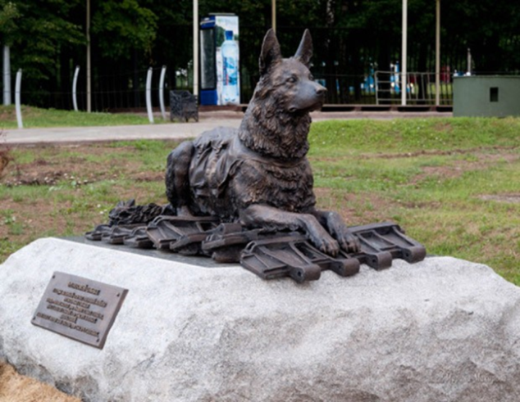
How dogs helped soldiers during the Great Patriotic War War

During the Great Patriotic War, about 68 thousand dogs were drafted into the army. Dogs fully helped people in the fight against the enemy. Here there are some facts:
- Hundreds of dogs worked as signalmen. They were called signaling dogs. They delivered 200,000 combat reports and stretched about 8,000 kilometers of wires.
- If doctors could not get to the seriously wounded soldiers, dogs did the job. They brought about 500,000 seriously wounded Red Army soldiers from the battlefield. Dogs warmed people in cold weather, drove them on special sled drags to the hospital.
- Many dogs were taught to throw themselves under enemy tanks. They were hung with explosives and called "sabotage dogs." The German tankers turned back, when they noticed sabotage dogs jumping out to meet them from the trenches of Stalingrad. During the war years, the dogs blew up more than three hundred German tanks.
- Dogs cleared more than 30 large cities of the USSR and Europe, finding more than 4,000,000 landmines and mines.
- Many dogs were awarded the medal "For Military Merit". Eternal memory to hero dogs!
Word box:
a signalman – связист wire - провод
sled drags – сани trench – траншея, окоп landmine – фугас, eternal – вечный,
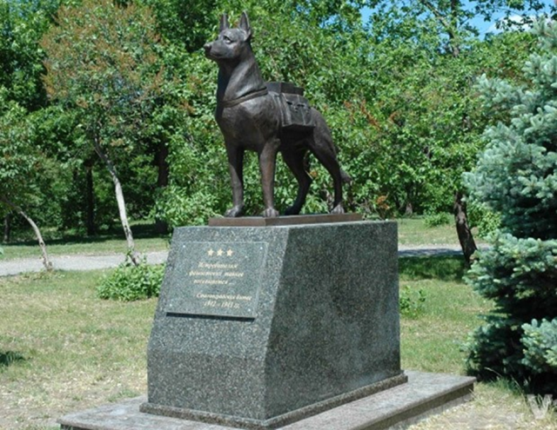
“For Military Merit” – «За боевые заслуги»

Activity:
Learn more about hero dogs: how dogs helped soldiers in World War II? Make a report, a project or a presentation.
Discuss:
Do you believe that dogs fully helped Russian soldiers during the war?
What can your pet-dogs do?
Can you rely on your dog in a difficult life situation?

Использованы материалы: 1) интернет-портал Губернiя Daily, 2) https://tailytales.ru

